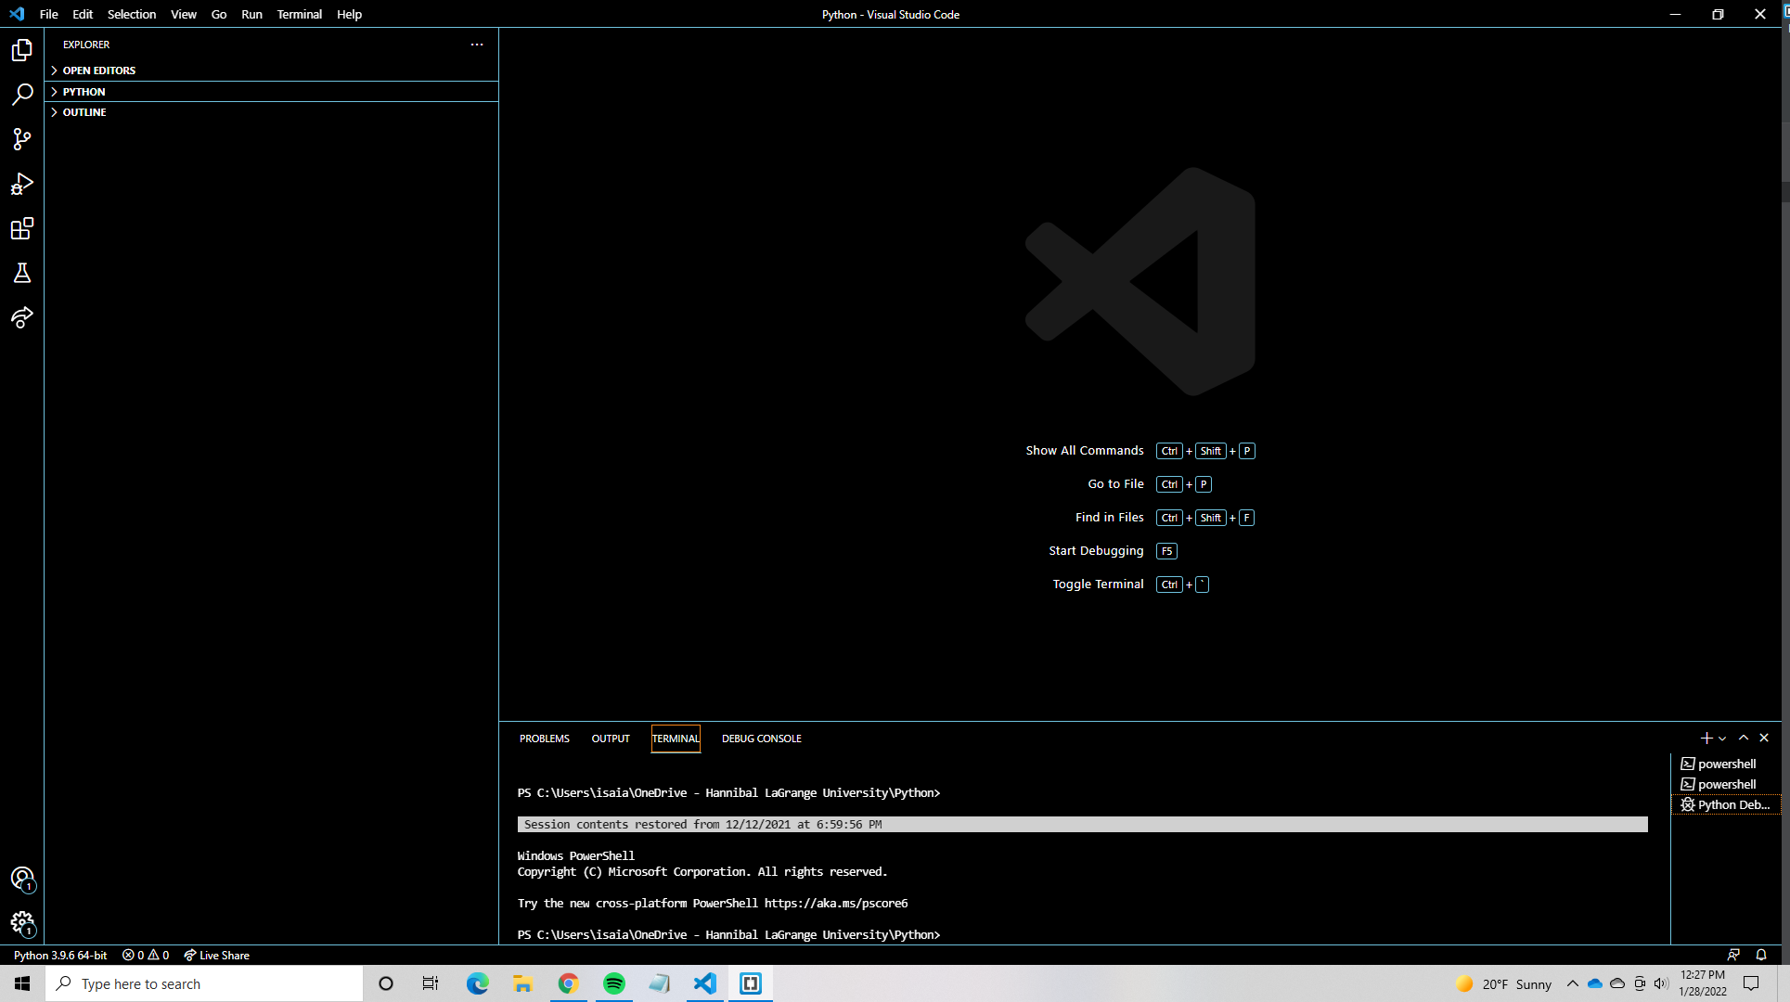

The first text editor I am using is Visual Studio Code, it has many cool features that most editors also have like being able to view a full file of different programs and you can switch back and forth between them from the sidebar. Another cool feature is that you can put code side by side so if you are comparing old and new code or you are referencing other code, you can easily look at both. You can also run certain languages of code in the terminal at the bottom of the application for ease of testing.

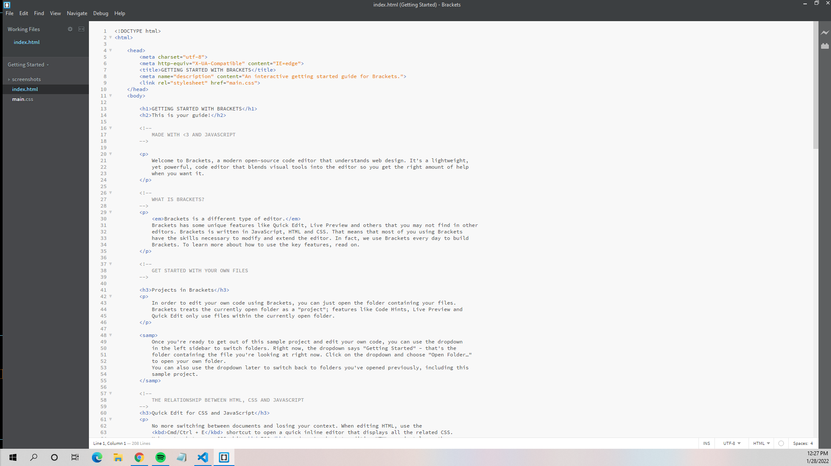

The second text editor I will be using is Adobe Brackets, Brackets has a similar file opening system on the sidebar for easy file cycling. You can also do side-by-side coding with split-screen viewing and editing. There are also a lot of editing features that make your code editing much easier as well as having a debugger built in to help error check your code.

This is the canvas source code along with its browser

This is the Room check form for the dorms as well as the source code for the page.

This is the validator site used on the canvas inbox website.

This is the text file being saved onto GitHub using visual studio.

This is the FileZilla application.